**CRIME AGAINST WOMEN IN INDIA**

“It was a quiet evening in a small town in India, where life usually moved at a slow and steady pace. But that evening, news spread quickly—a young woman had been attacked right in the middle of town. As neighbors gathered and whispered about the incident, it became clear that this was not just an isolated event; it was part of a much bigger and troubling pattern seen across the country.”

For years, similar stories have been piling up—each one showing the ongoing struggle women face to live safely in a world that should protect them. From busy cities to remote villages, the threat of violence is a constant worry, making everyday life dangerous for many women.

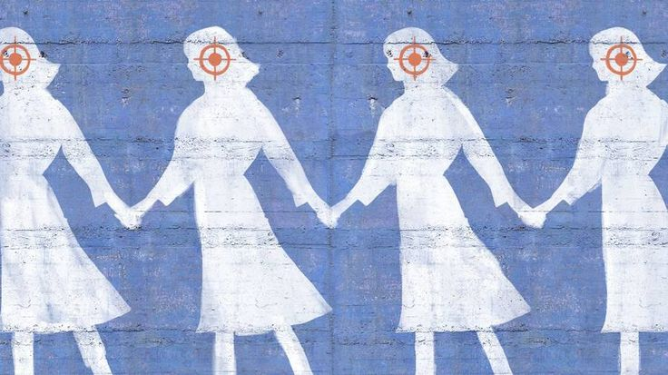

These stories together show a society dealing with a long-standing and widespread issue. The statistics might be shocking, but they only show part of the picture. Behind each number is a person whose life has been changed, a dream that has been lost, and a future that has been damaged. This blog looks at data from 2001 to 2021 to uncover the trends and patterns of this crisis and calls for strong action to address it. The need for change is urgent, and it's time to face this issue head-on.

Over the past twenty years, crimes against women in India have risen sharply. Whether it's rape, domestic violence, or dowry deaths, the numbers have been steadily increasing, showing a serious problem in society.

In 2001, there were far fewer reported cases, but by 2021, the numbers had more than doubled. Certain years saw big jumps in cases, often linked to social and political events or changes in law enforcement. For example, after the 2012 Delhi gang rape case, there was a major public outcry, which led to more cases being reported and a greater willingness to speak out about these crimes.

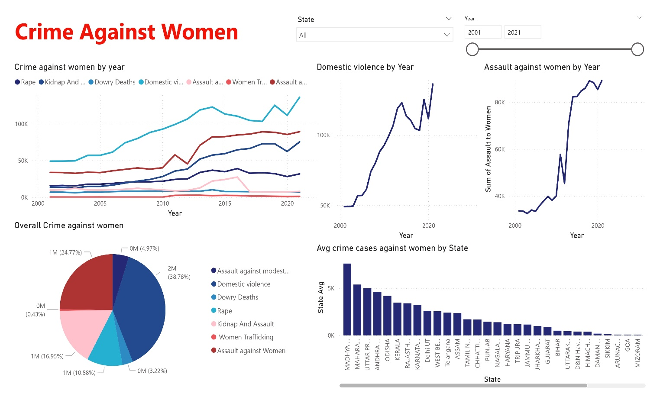

(Data : https//data.govt.in , visualization Software : PowerBI)

Geographic Hotspots

Crimes against women are not spread evenly across India. Some states have higher rates of crime against women like Madhya Pradesh , Uttar Pradesh , Maharashtra , Andhra Pradesh , Odisha etc , on an Average however specific crimes are prominent in specific states like ,

Domestic Violence cases can be majorly seen in West Bengal , Rajasthan , Andhra Pradesh , Uttar Pradesh , Maharashra and Assam.

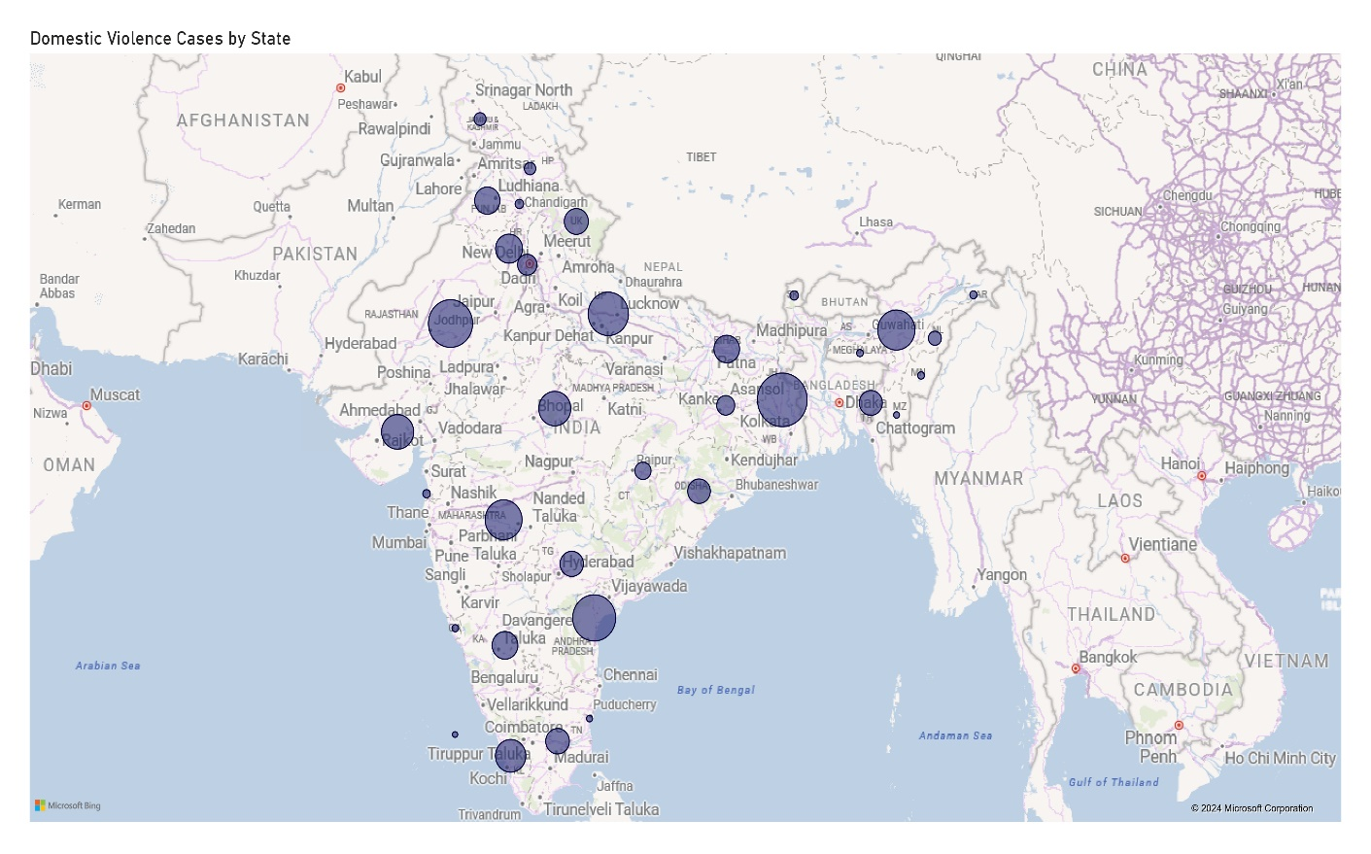

Assault cases can be majorly seen in Madhya Pradesh , Maharashtra, Uttar Pradesh , Andhra Pradesh , Odisha, Kerela and Rajasthan

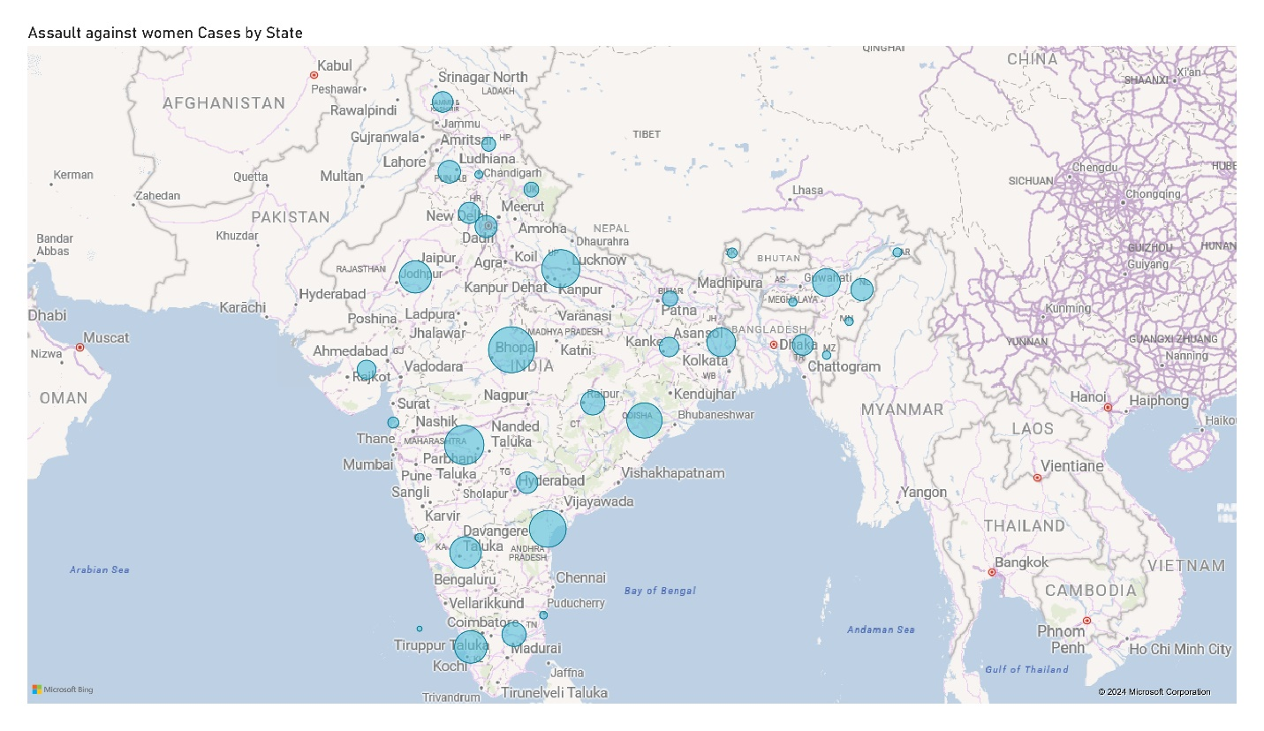

Rape cases are majorly in Madhya Pradesh , Uttar Pradesh , Rajasthan, Maharashtra , Assam , West Bengal , Kerela , odisha , Punjab and Bihar .

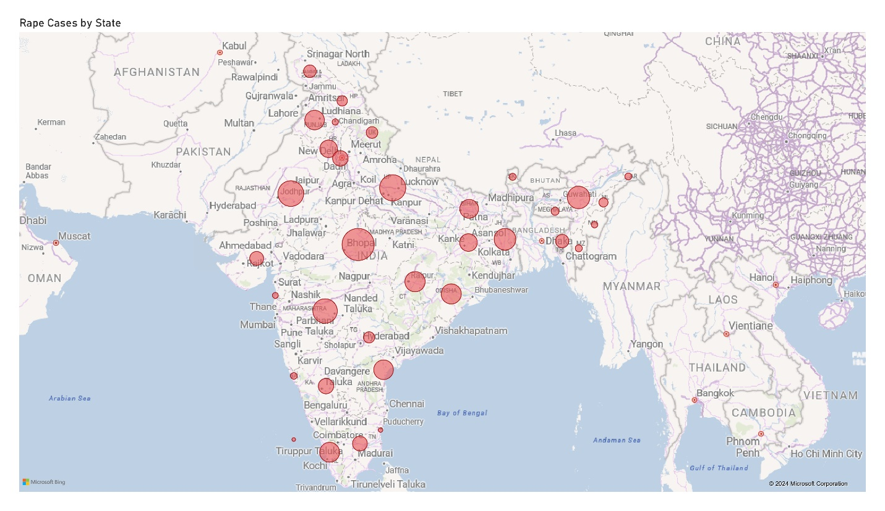

Therefore , maps made from the data show these hotspots, highlighting areas where crimes are more common. This would help identify regions that need more focused policies. Also to note , differences in crime rates can be due to factors like population density, local culture, and how well law enforcement works.

The Crime Pie

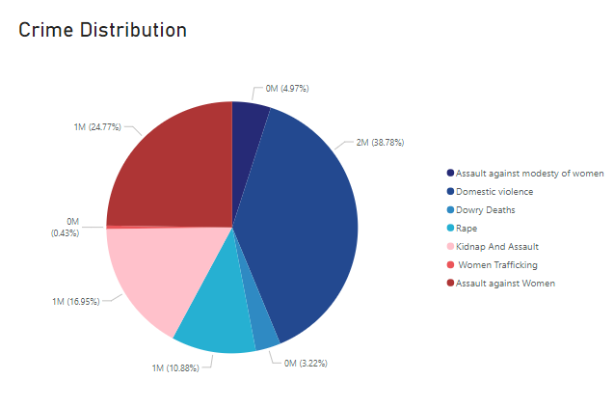

Domestic violence and assault have increased the most and represents the greater section of the Crime Pie. These issues, often hidden, have become more visible due to better reporting and awareness with time. The rising numbers highlight that more needs to be done to protect and support victims of these Crimes.

Domestic violence affects all areas and communities, showing that women are increasingly speaking out. However, this also points to the need for stronger legal protections and better support systems for survivors.

The growing crime numbers suggest that current measures are not enough. Even with laws meant to protect women, enforcement is often inconsistent, and societal attitudes can prevent victims from seeking justice.

Crimes like dowry deaths and trafficking, though less reported, remain persistent. This indicates that cultural practices and economic pressures continue to drive these issues, showing a need for policies that address the root causes.

Now what?

The data calls for action. The data from 2001 to 2021 shows that crimes against women in India are not isolated events but part of a larger issue that needs immediate action. So, It's not enough to just recognize the problem; we need concrete steps to tackle it. This includes better law enforcement, more funding for women's shelters, and educational programs to change societal attitudes. There is a need to focus on the identified hotspots, with targeted actions for these regions. Understanding the data trends can help address the root causes and work towards a society where women are safe from violence.

It’s time to turn awareness into action and work together to build a safer future for women everywhere!

* Ananya Billawaria